**portfolio**

**SIT162**

Name: Lingxiao Meng

ID: 217643351

element 1

* This week I choose a website to host mine portfolio and the website is: https://github.com/MENGLINGXIAO2/SIT162-Ass3

element 2

This week I learnt how to use Photoshop, and I follow by tutorial <https://www.photoshoptutorials.ws/photoshop-tutorials/photo-manipulation/create-mystic-lady-photo-manipulation/>

PS is a software that can edit the picture, People can edit all kinds of things in pictures.

It is a photo that I found in google

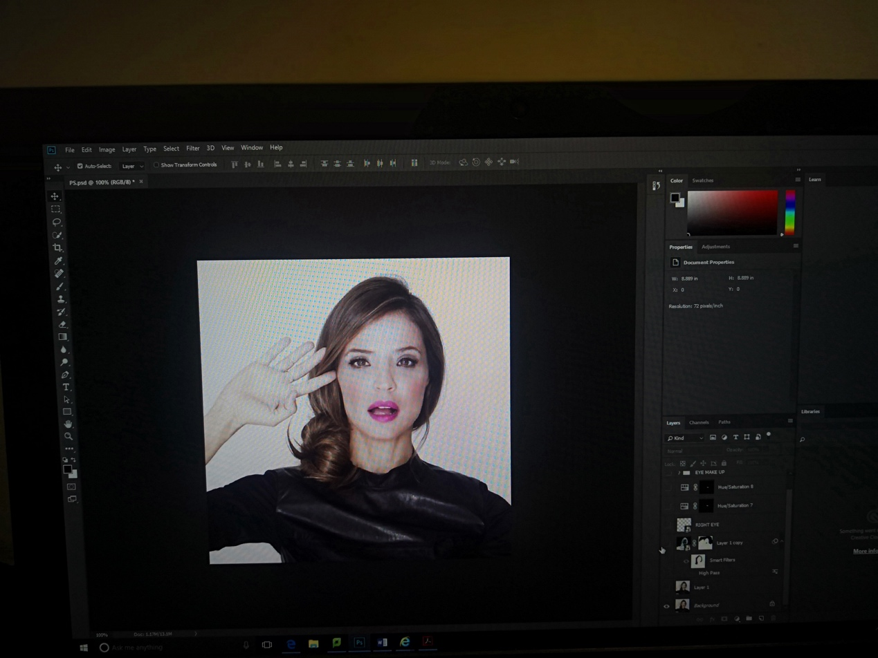

Then I invert ctrl+I, next I change the layer to smart layer, next I change layers to overly Next I mask the eyes, nose, lips and upper hair, next I mask face and hair in smart filters, and I get this:

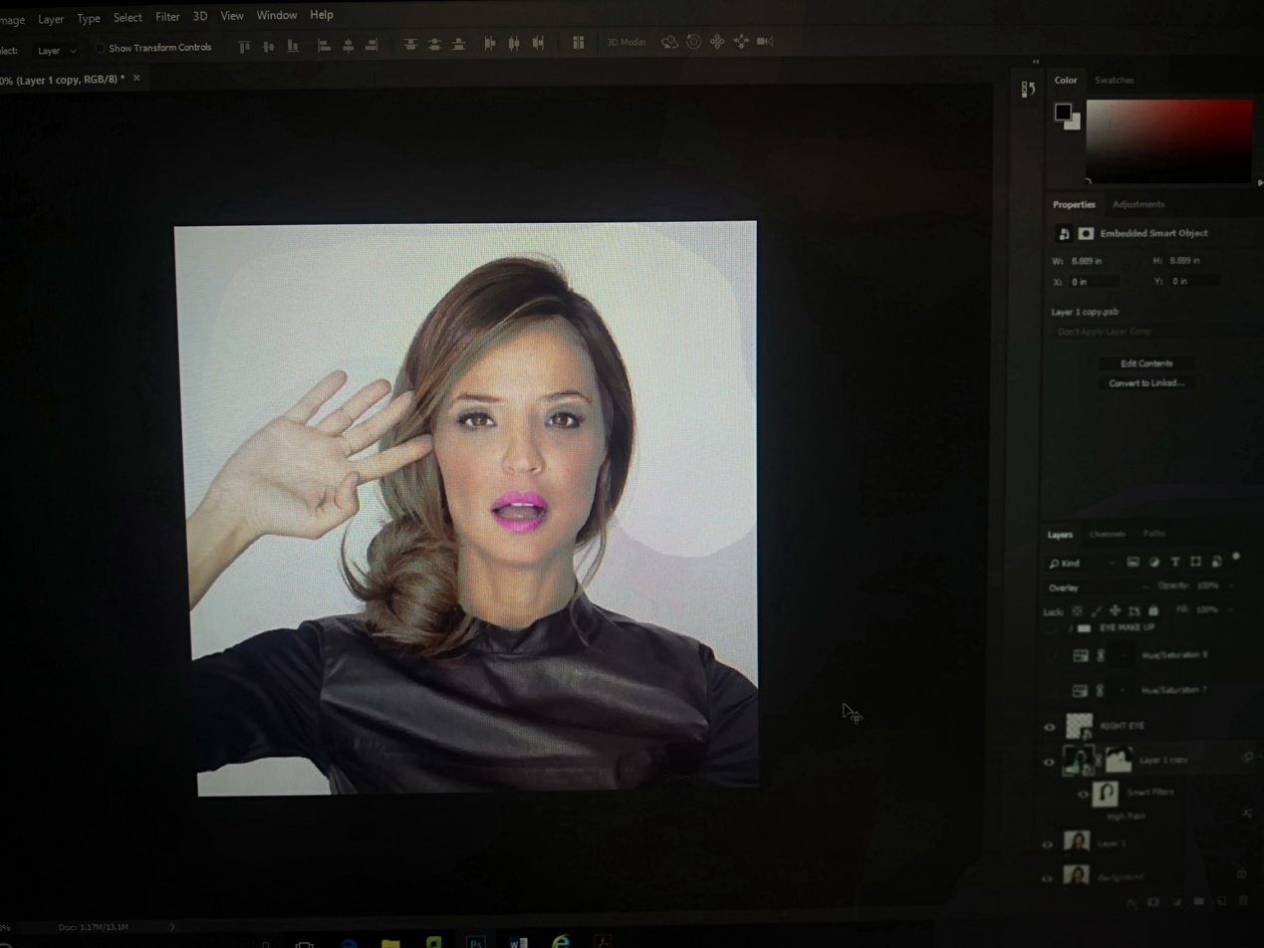

Next I add some eye shadow to both eyes, and I get the result like it:

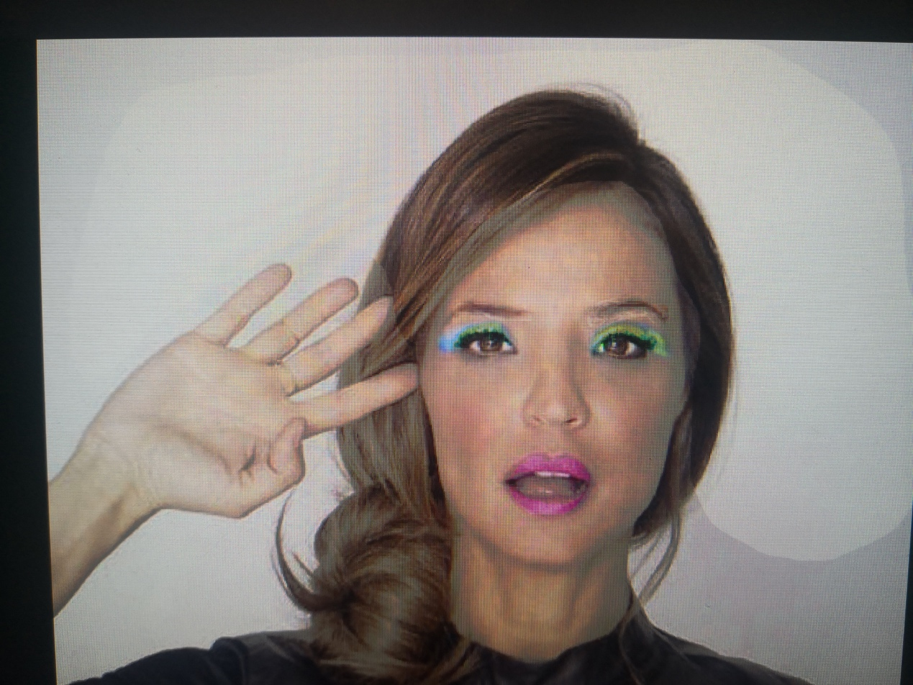

Then ,I add the rouge for woman ,it looks like that:



Finally, I add the eyebrush for women, the finally result is like that:

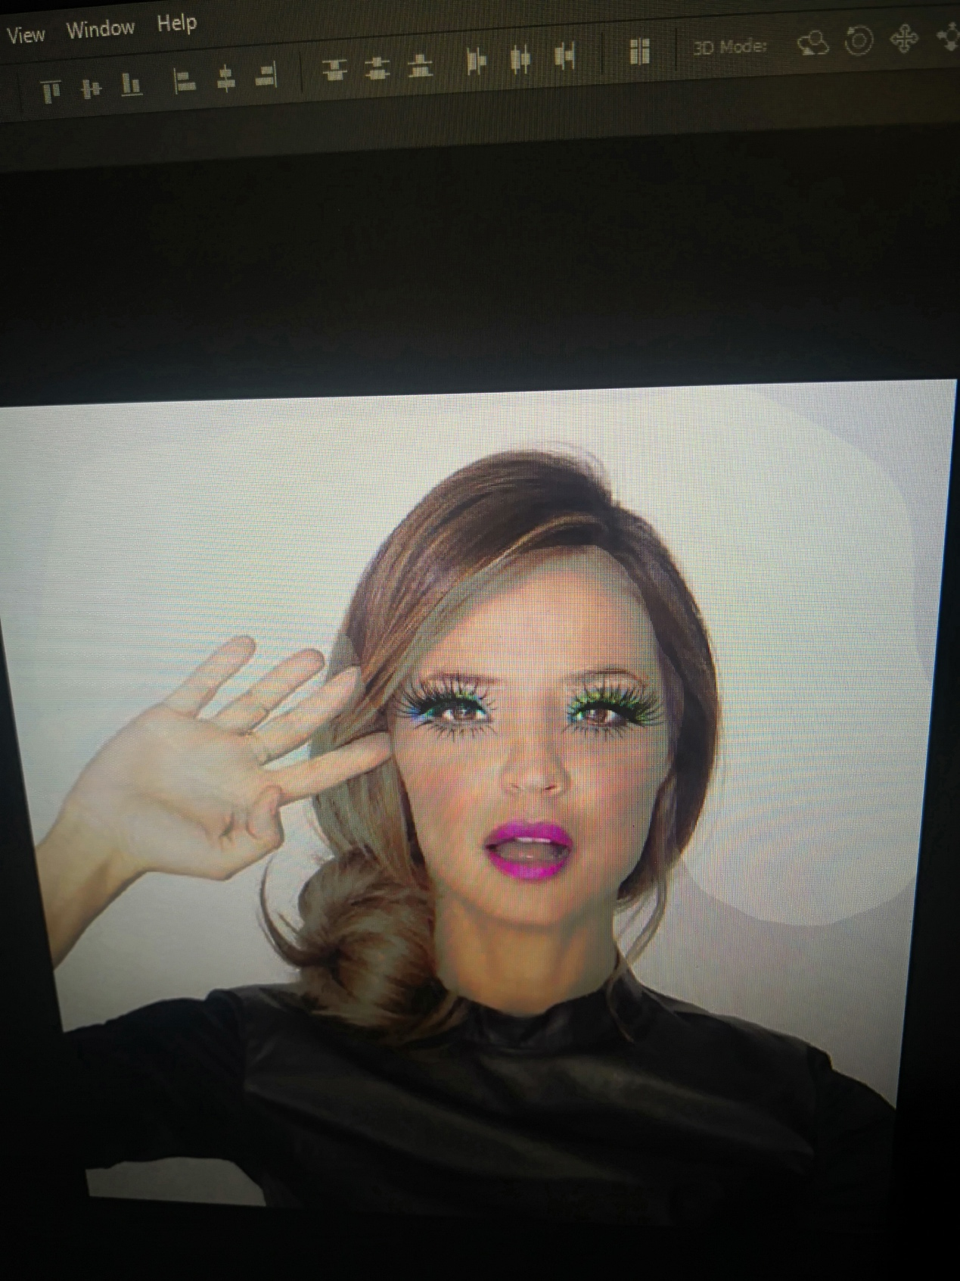

element 3

1. This week I learnt how to creative a website, I use HTML5 and javascript to creative a website, I learnt it from the <https://glitch.com/~javascripting> , it tells me basic information about JavaScript and how to creative a JavaScript, JavaScript is scripting language. It can be applied to web and HTML.

It is my screenshots of my javascripts

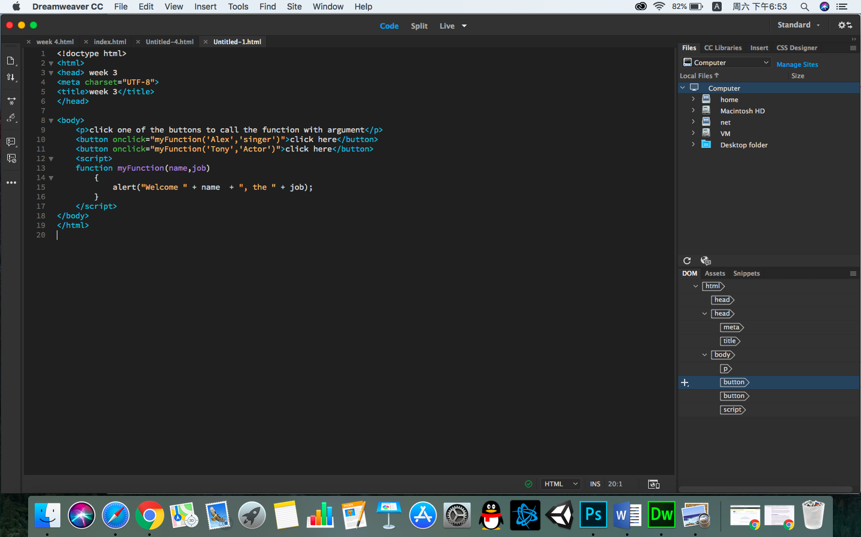

I input a sentence in my website which is click one of the buttons to call the function with argument, and two buttons in my web, in javascript, I input a function with parameter, then when I click the button, the sentences can appear.

It is the screenshot of my website:

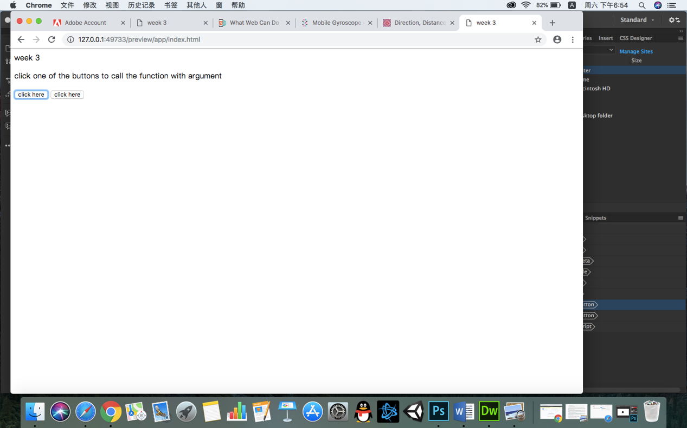

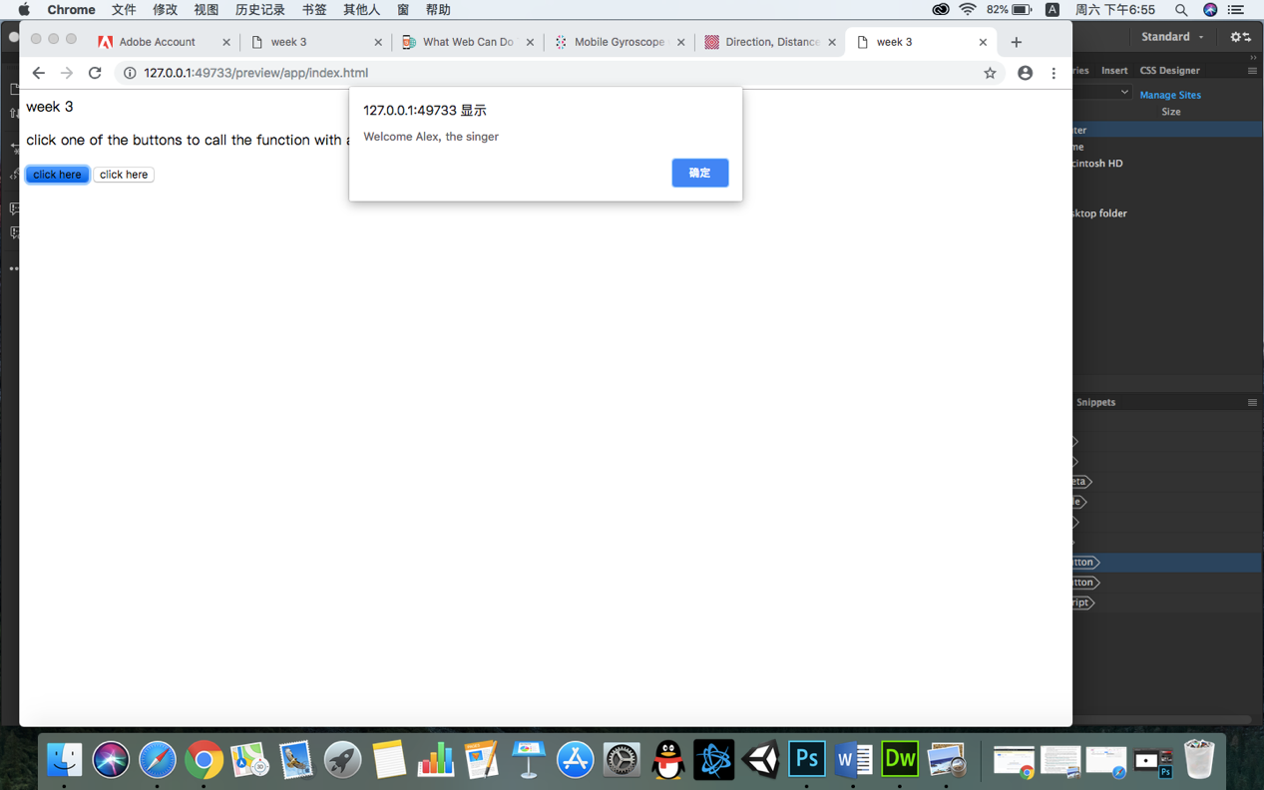

element 4

1. This week I learnt Collecting and Presenting Sensor Data, I learnt it from http://www.asterixcreative.com/ blog/mobile-gyroscope-with-javascript-and-quaternions-programming-tutorial-part-1/ ,

Html structure:

I used div, h3, Span and P These are all popular labels. Selector I use class, because class can define more than one element.

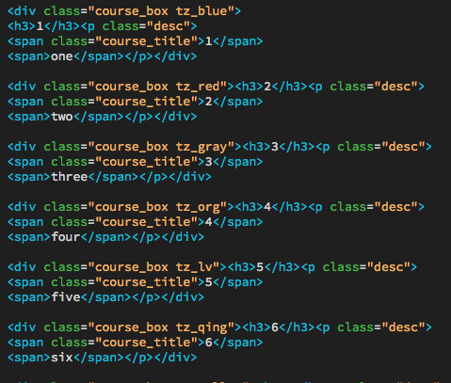

CSS style sheet

I have defined some basic styles, such as color, margin and size. Selectors are all class selectors.

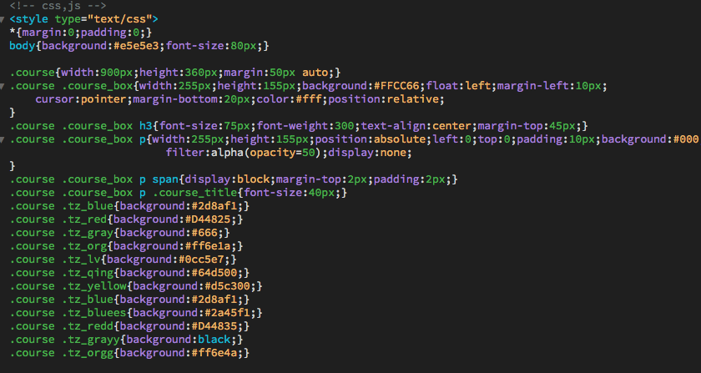

JavaScript and jQuery

First, introduce the third party plug-in that is jQuery, then get HTML elements that is “course_box”, the type is class and use hover that is effect when the mouse is focused.

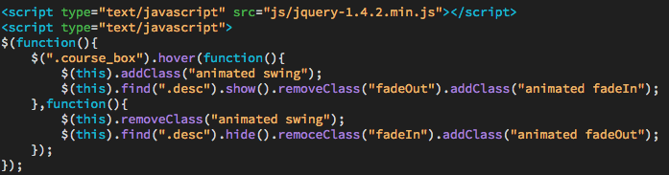

jQuery

It is my screenshot of my website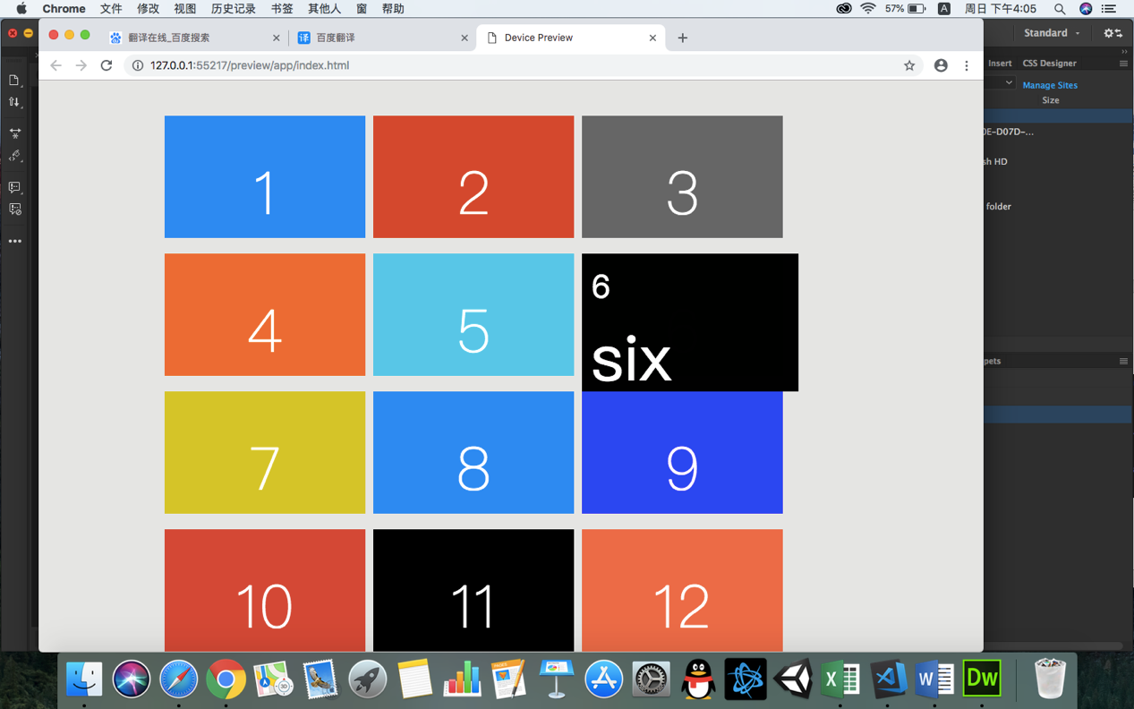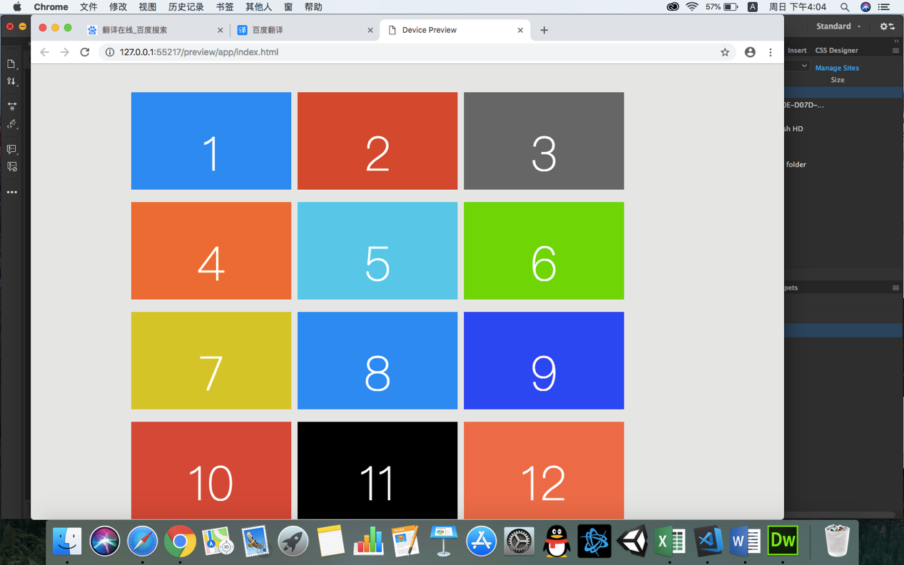

element 5

This week I learnt Image analysis - identify features in pictures , I learnt it from https://sightengine.com/

This is a picture I get in google:



And then I analysis this picture, and I get this:

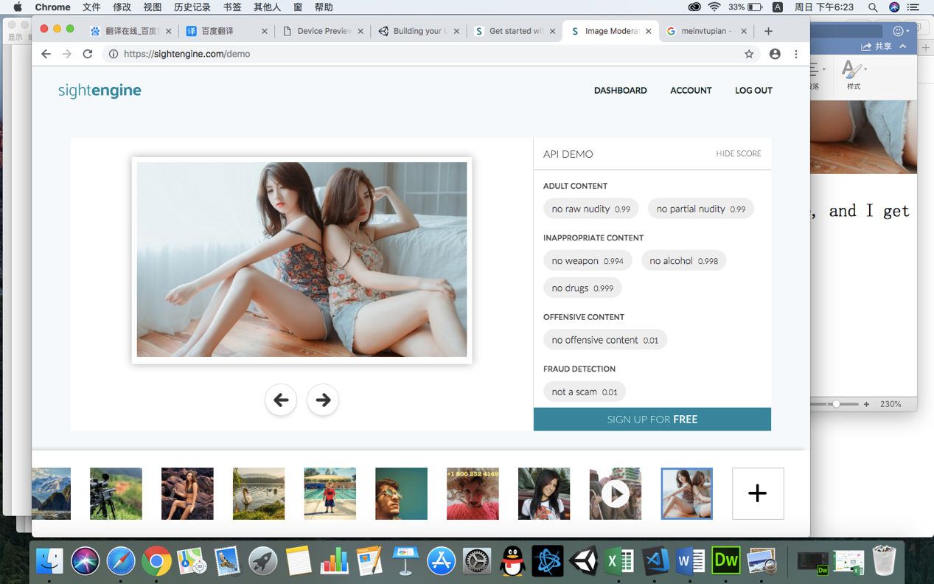

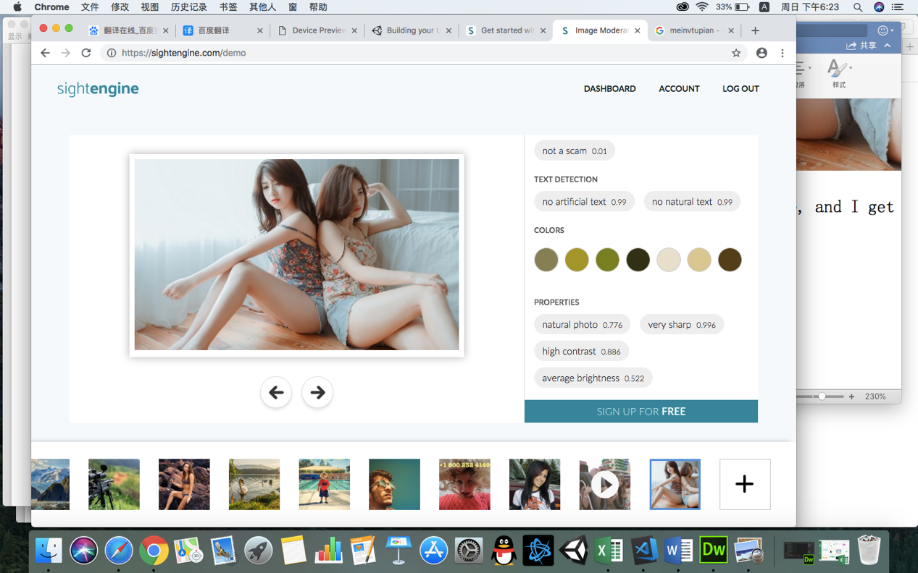

It is another picture I analysis:



The result is:

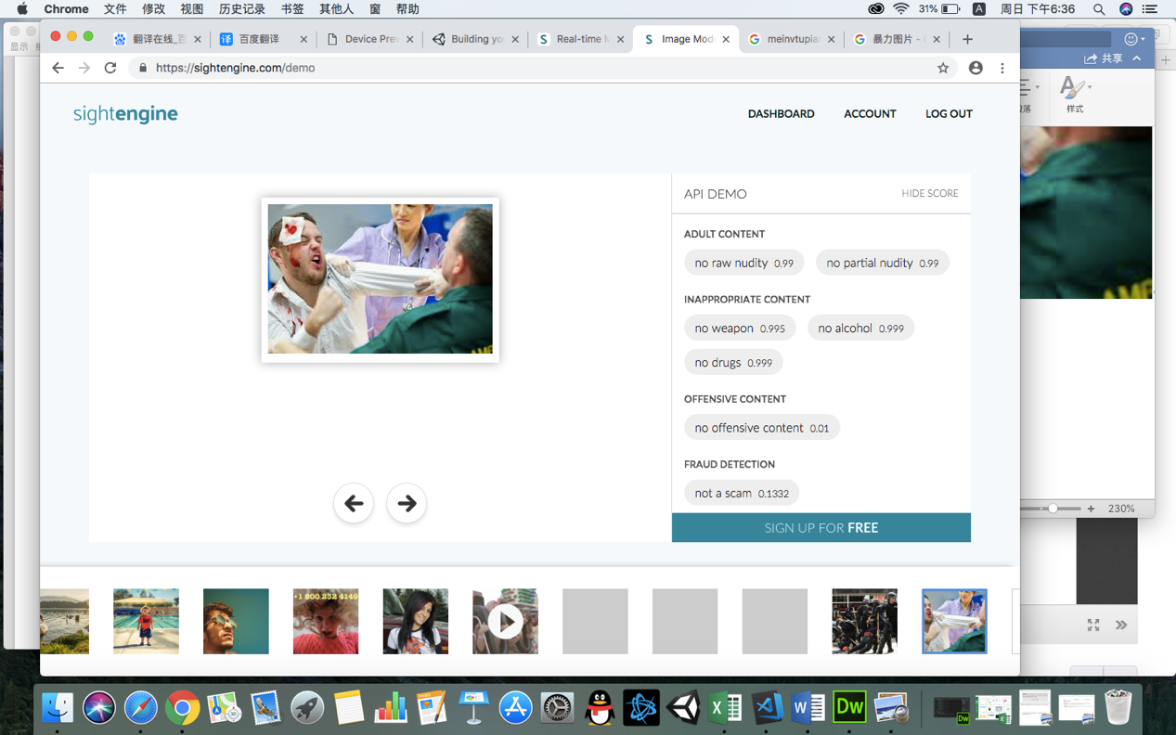

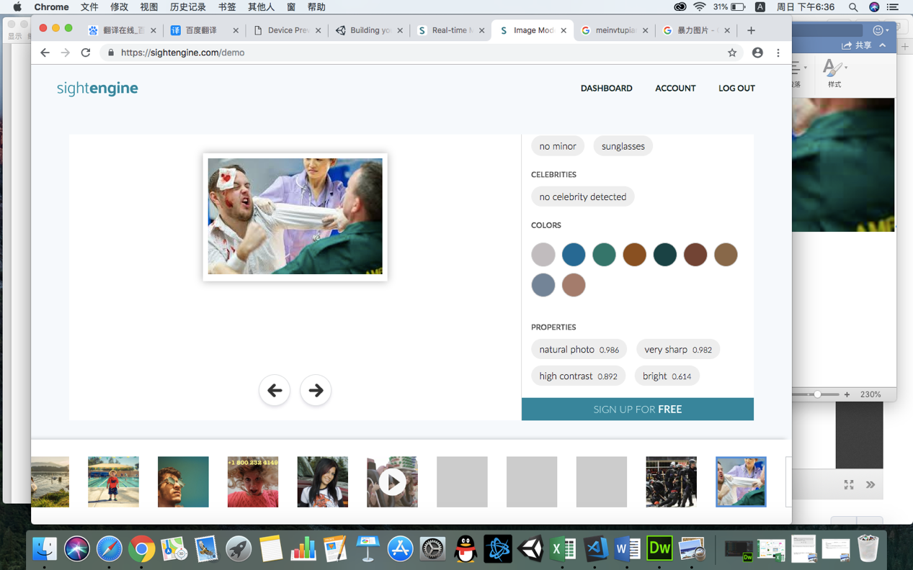

element 6

1. This week I learnt **User Interfaces and Mobile Applications, I follow by tutorial**

https://unity3d.com/learn/tutorials/topics/mobile-touch/building-your-unity-game- ios-device-testing

I follow tutorial step by step, first I create a project, and then I download and import simple mobile placeholder from asset store ,and I get this

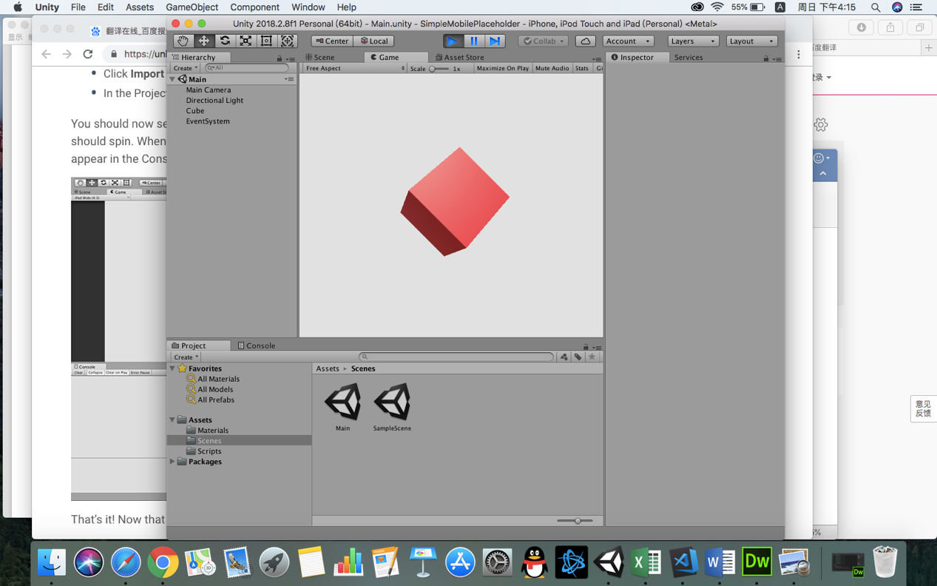

Then I continue do it, and I get it finally:

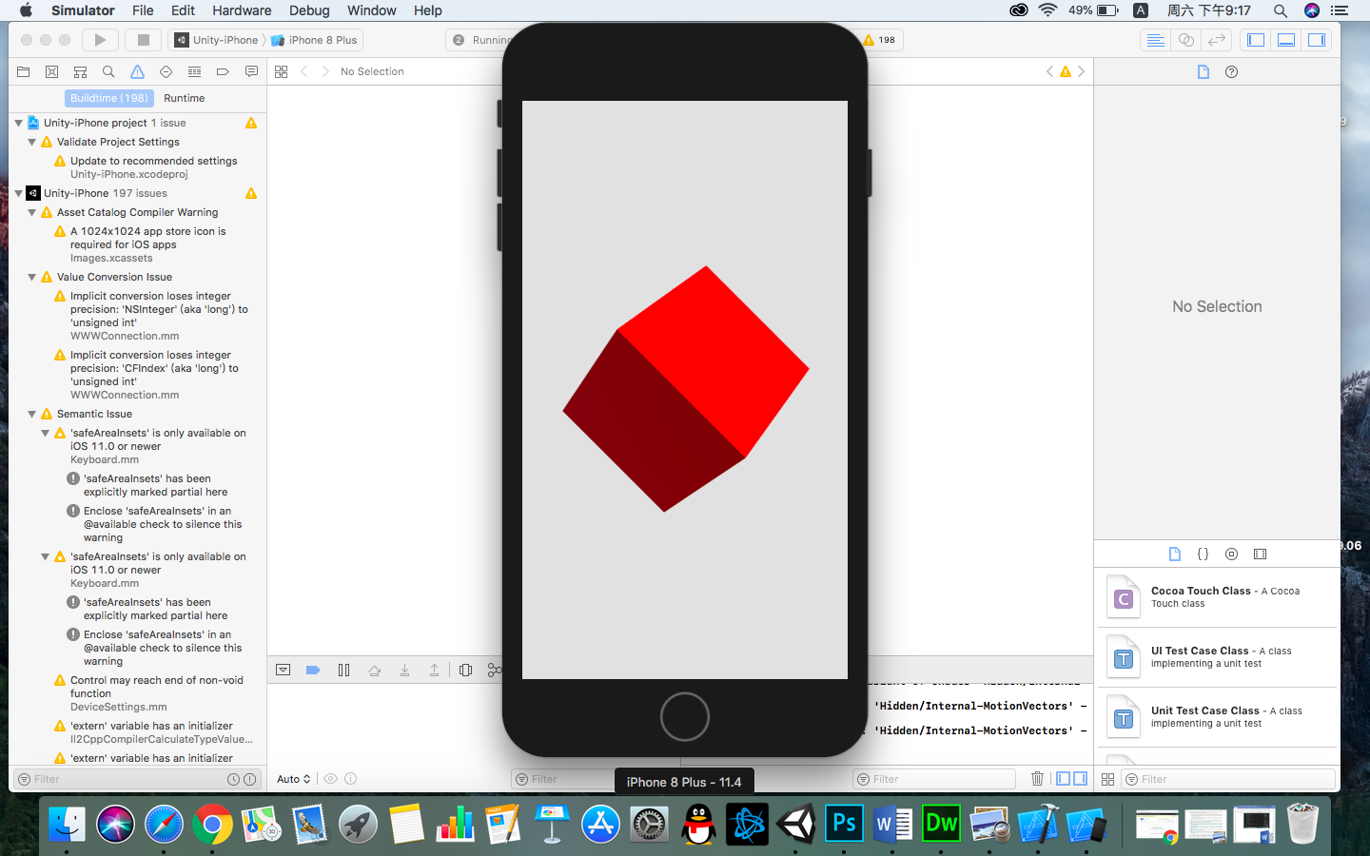

element 7

This week I learnt **Virtual and Augmented Reality, I follow tutorial by** https://library.vuforia.com/ articles/Training/getting-started-with-vuforia-in-unity.html

First of all, I used vuforia's sdk, vuforia's SDK is more popular, it has graphics recognition, cloud storage and scene recognition functions. Through the tutorial, I made a case about augmented reality. Firstly, download an identification diagram.

This is recognition chart

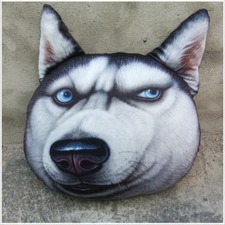

This is the end result, and we can see that by augmented reality we can recognize pictures and display models

